Downloading and Installing the Cloudera VM Instructions(Windows)

**Reference link : https://youtu.be/SmS8x6xAsB4**

Learning Goals

In this activity, you will:

∙ Install 7-zip

∙ Download and Install VirtualBox.

∙ Download and Install Cloudera Virtual Machine (VM) Image.

∙ Launch the Cloudera VM.

**Instructions**

Please use the following instructions to download and install the Cloudera Quickstart VM with VirutalBox before proceeding to the Getting Started with the Cloudera VM Environment video.

**1. Install 7-zip**

https://www.7-zip.org/download.html

2. **Install VirtualBox.**

https://www.virtualbox.org/wiki/Download_Old_Builds_6_1

3. **Download the Cloudera VM.** Download the Cloudera VM from

https://downloads.cloudera.com/demo_vm/virtualbox/cloudera-quickstart-vm 5.13.0-0-virtualbox.zip

The VM is over 4GB, so will take some time to download.

4. **Unzip the Cloudera VM**:

Right-click cloudera-quickstart-vm-5.13.0-0-virtualbox.zip and select “Extract All…” 2. **Start VirtualBox**.

3. **Begin importing**. Import the VM by going to File -> Import Appliance 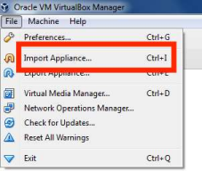

**4. Click the Folder icon.**

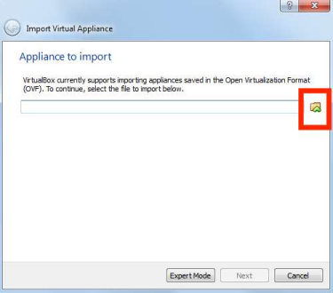5. **Select the cloudera-quickstart-vm-5.13.0-0-virtualbox.ovf** from the Folder where you unzippedthe VirtualBox VM and click Open.

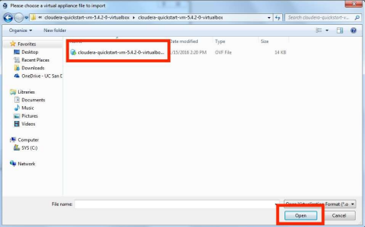6. **Click Next** to proceed.

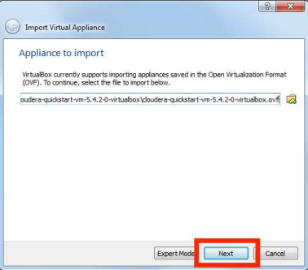**7. Click Import.**

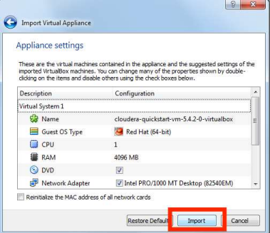8. **The virtual machine image will be imported.** This can take several minutes.

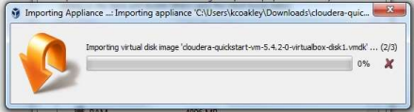9. **Launch Cloudera VM.** When the importing is finished, the quickstart-vm-5.13.0-0 VM will appearon the left in the VirtualBox window. Select it and click the Start button to launch the VM.

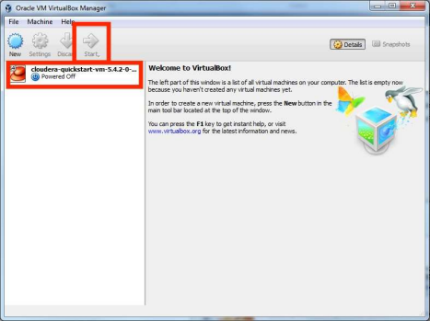10. **Cloudera VM booting.** It will take several minutes for the Virtual Machine to start. The bootingprocess takes a long time since many Hadoop tools are started.

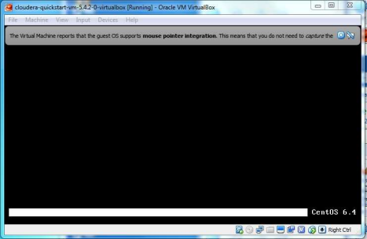11. **The Cloudera VM desktop.** Once the booting process is complete, the desktop will appear witha browser.

